Table 1

|  |  |  |  |  |  |  |
| --- | --- | --- | --- | --- | --- | --- |
|  |  |  |  | | |  |
|  |  |  |  | |  |  |
|  |  |  |  |  |  |  |
|  |  | |  |  |  |  |

Table 2

|  |  |  |  |
| --- | --- | --- | --- |
|  |  |  |  |
|  |  |  |  |
|  |  |  |  |
|  |  |  |  |
|  |  |  |  |

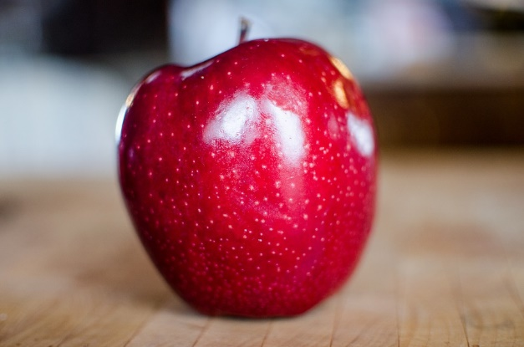

Figure 1